Candidate/Grad Management

# Testing Results (Backend)-

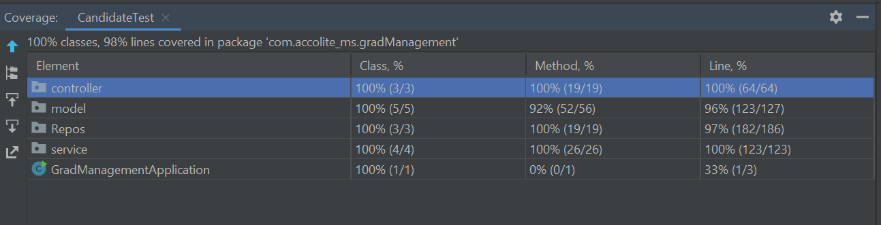

## Controllers:

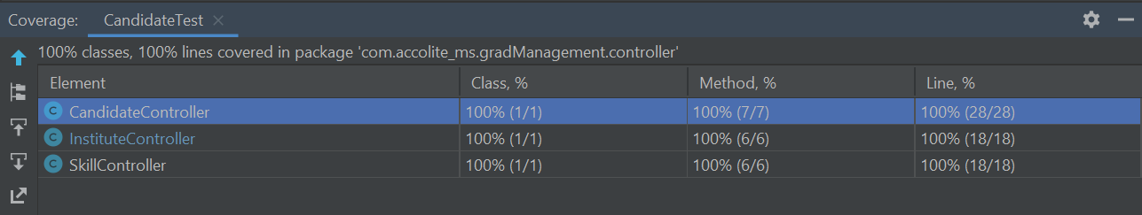

## Services:

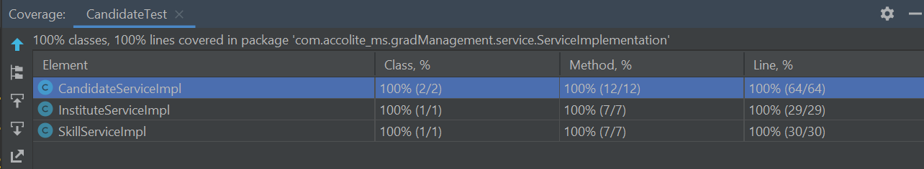

## Daos/Repos:

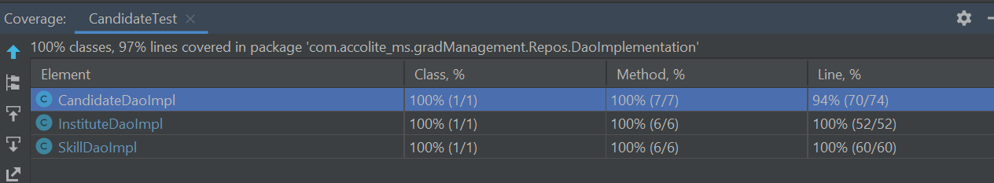

# UI (Frontend)-

## Home:





## Logged In:



## Skills:

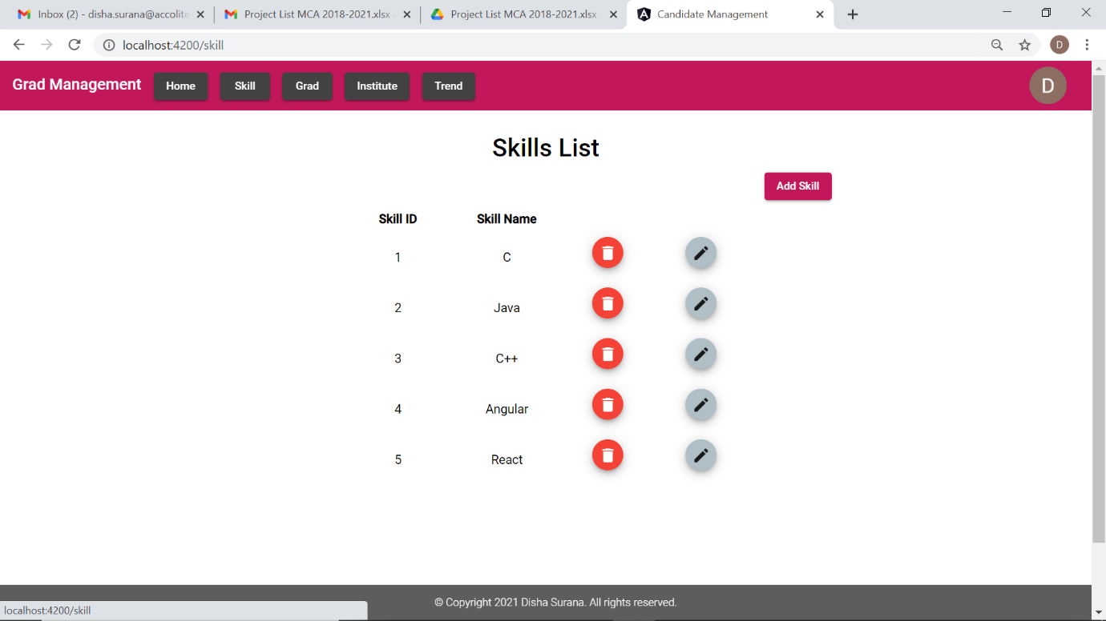

## Add Skill:

## Institute:

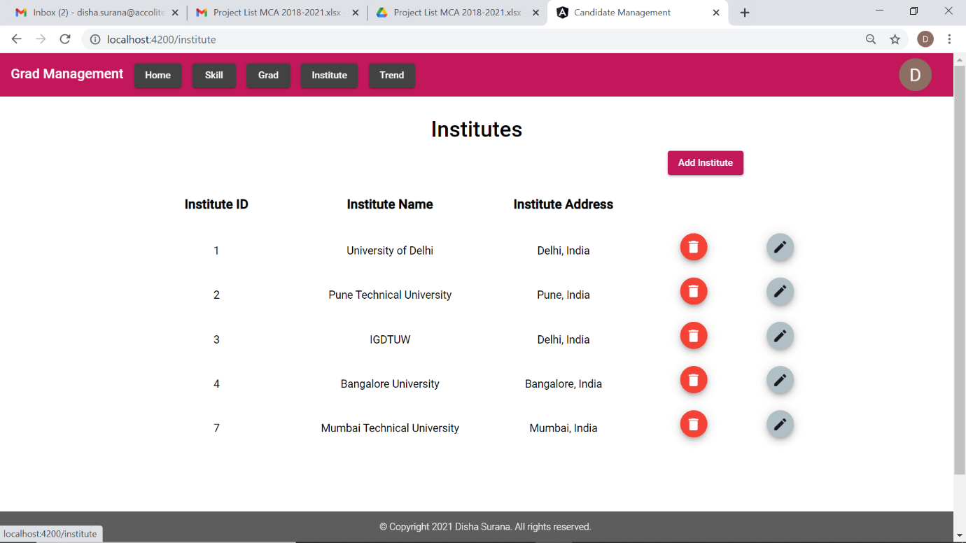

## Edit institute:

## Grad List:

## Grads filter by year(2021):

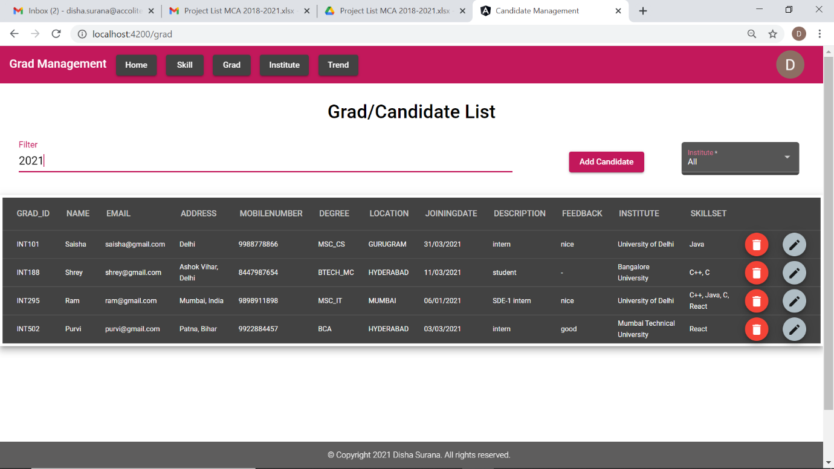

## Grads filter by Institute- University of Delhi:

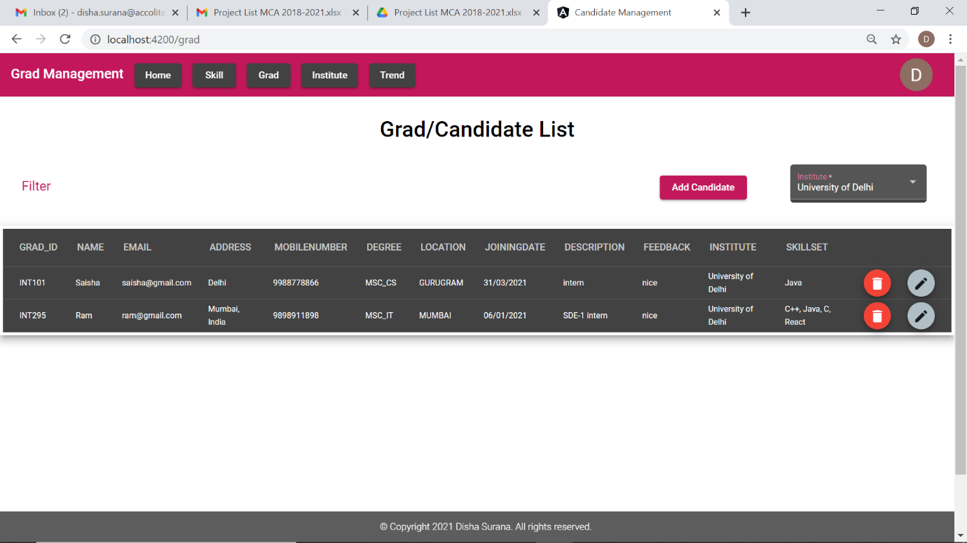

## Grads filter by Location- Hyderabad

## Edit Grad:

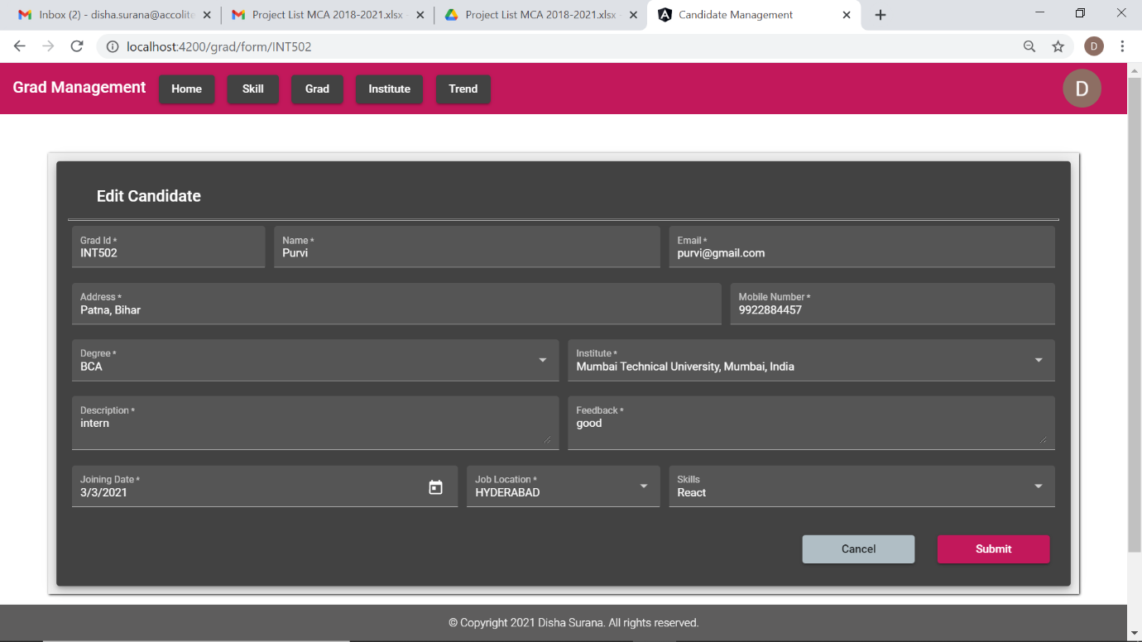

## Trends:

* Location wise Candidate Trend
* Degree wise Candidate Trend
* Institute wise Candidate Trend
* Skill wise Candidate Trend

### PIE

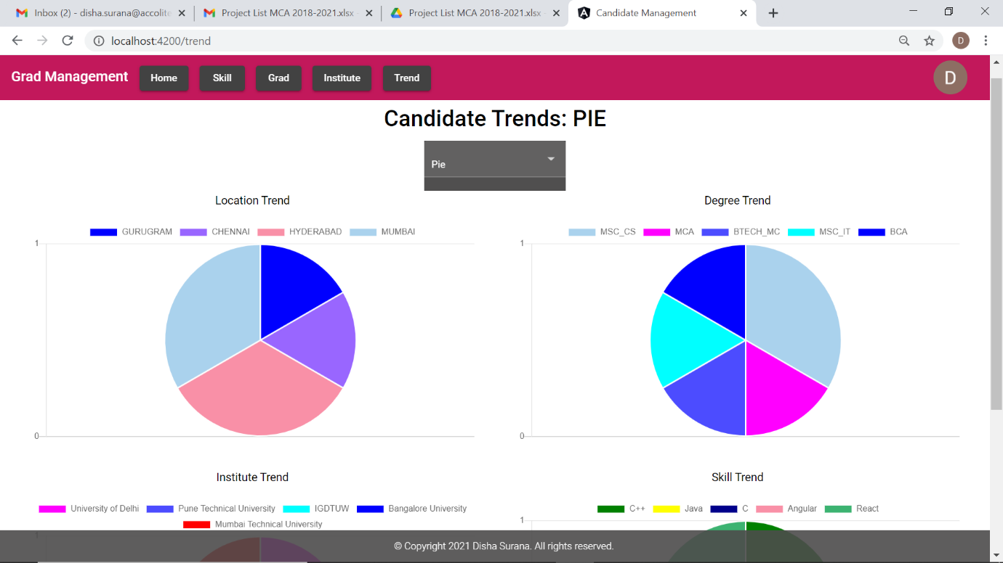

### BAR

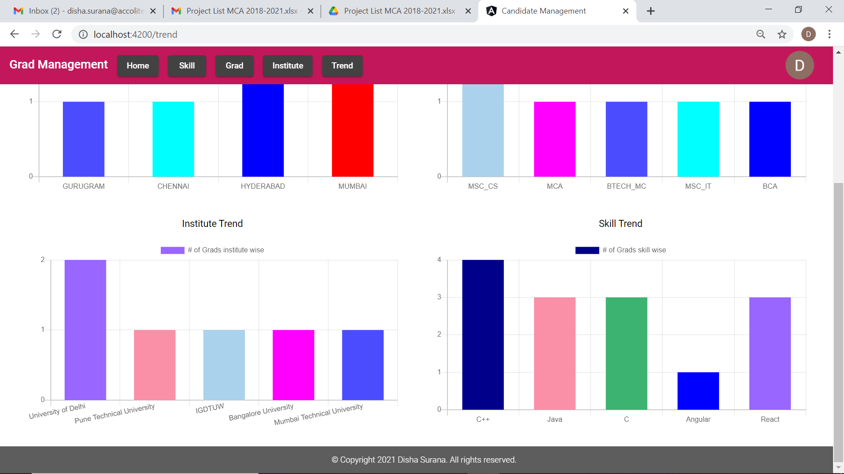

### LINE

### DOUGHNUT

### RADAR

Disha Surana